

**Project Proposal Coversheet**

Please fill in your details in the yellow shaded areas below.

|  |  |  |  |  |  |  |  |  |  |  |
| --- | --- | --- | --- | --- | --- | --- | --- | --- | --- | --- |
| Surname | Wijesuriya | | | | Other Name(s) | | | Wijesuriya Arachchige Don Nicum Santha | | |
| Registration No | | |  | | Email | | nickalexryan1991@gmail.com | | |  |
| Contact Number | | | | **0773885617** | | | | | | |
| School of Study | | | | **National School Of Business Management** | | | | | | |
| Program of Study | | | | **Final Project** | | | | | | |
| Batch code | | | |  | | | | | | |
| Tentative Project Title | | | | **Impact of ICT on Education Field in Students of University Sri Jayawardanapura** | | | | | | |
| Project Manager’s Name | | | |  | | | | | | |
| Supervisor Name (if available) | | | | **Nadeera Ahangama** | | | | | | |
| Due Date | | **2014/12/14** | | Submission Date | | **2014/12/14** | | | Word Count |  |

**Declaration:**

|  |  |
| --- | --- |
| 1. I understand that all forms of plagiarism and unauthorised collusion are regarded as academic dishonesty by the institute, resulting in penalties including failure of the unit of study and possible disciplinary action. 2. This work is substantially my own, and to the extent that any part of this work is not my own I have indicated that it is not my own by acknowledging the source of that part or those parts of the work. 3. The assessment has not been submitted previously for assessment in this or any other unit, or another institution. 4. I have retained a duplicate copy of the assignment. | |
| Signature of the Student |  |

Introduction

Day by day world changes. Technology changes more rapidly than man change himself. In very old days we used black boards for teaching purpose but now we use presentations to do lectures. So in the field of education, methods of teaching have also changed. This Research is about the impact of new technology on Education field in Sri Lanka.

Justification / Rational of this project

In present days education field has become more computerized. Students use online references and lecturers will use Web in order to provide notes to students. Which in old days took a lot of time and a lot of effort to do. By adapting to this new technology mind of students and Lecturers might have been changed. Some people may like this new way of teaching and some may not. Most of the institutes only use new technologies of educations. Some Students with low facilities finds it difficult to find notes then.

Research Questions

* What are the Students attitudes towards ICT?
* Do students use ICT to support their studies?
* Does ICT impact students Study habits?

Project Objectives and Scope

Scope: - University of Sri Jayawardanapura

Objectives:

* To Study new Technologies of Education
* To Gather Students ideas of this technology changes
* Analyze and generate a research report

Conceptual Framework

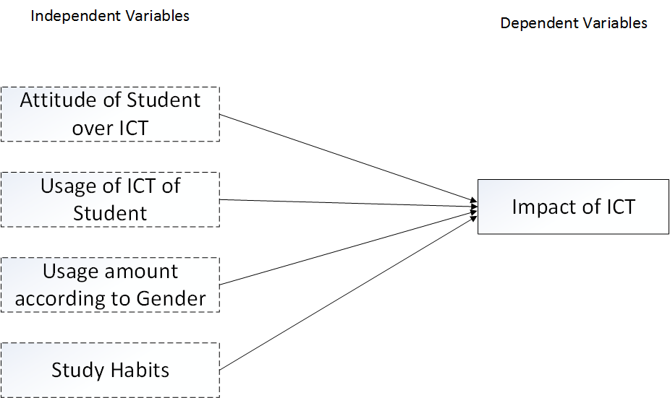

Literature Review

ICT on learning have become more widely used in present days. There are many different digital instruments used for this purpose. Primarily used materials are Computers and Internet.

From a recent research in University of Buea, Cameroon it was found that about 81% of the students in that university is using ICT in any way. And it was discovered there is an ICT usage difference according to gender of the student. Also that research discovered that about 83% students use ICT positively for educational purposes. And secondly 80% students go internet to find information they require for their studies which are not available in the school library.

References

The impact of ICT on students’ study habits. Case study: University of Buea, Cameroon, (Mbah, 2015)